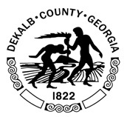

DeKalb County Communications openings

DeKalb County Government is seeking applicants for the following:

Public Information Officer
Press Secretary
Social Media Manager

For position details visit - https://www.dekalbcountyga.gov/human-resources/employment-opportunities.

